**Input & Output Devices**

**Input Devices:** An Input device can send data to another device, but it cannot receive data from another device. Examples of input devices include the following:

* **Keyboard and Mouse -** Accepts input from a user and sends that data (input) to the computer. They cannot accept or reproduce information (output) from the computer. 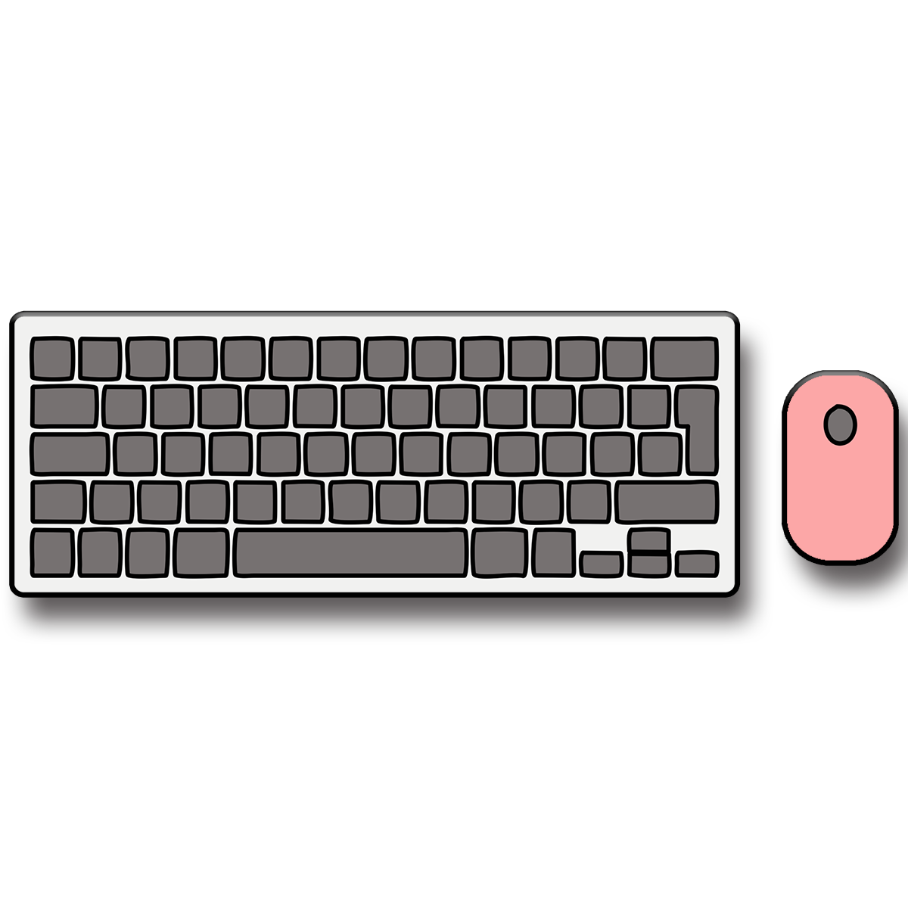
* **Microphone** **-** Receives sound generated by an input source, and sends that sound to a computer.



* **Webcam** **-** Receives images generated by whatever it is pointed at (input) and sends those images to a computer.

**Output Devices:** An output device can receive data from another device and generate output with that data, but it cannot send data to another device. Examples of output devices include the following:

* **Monitor** **-** Receives data from a computer (output) and displays that information as text and images for users to view. It cannot accept data from a user and send that data to another device.
* **Speakers -** Receives sound data from a computer and plays the sounds for users to hear. It cannot accept sound generated by users and send that sound to another device.
* 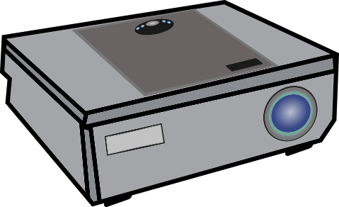**Projector -** Receives data from a computer (output) and displays, or projects, that information as text and images onto a surface, like a wall or screen. It cannot accept data from a user and send that data to another device.